MONGO DB

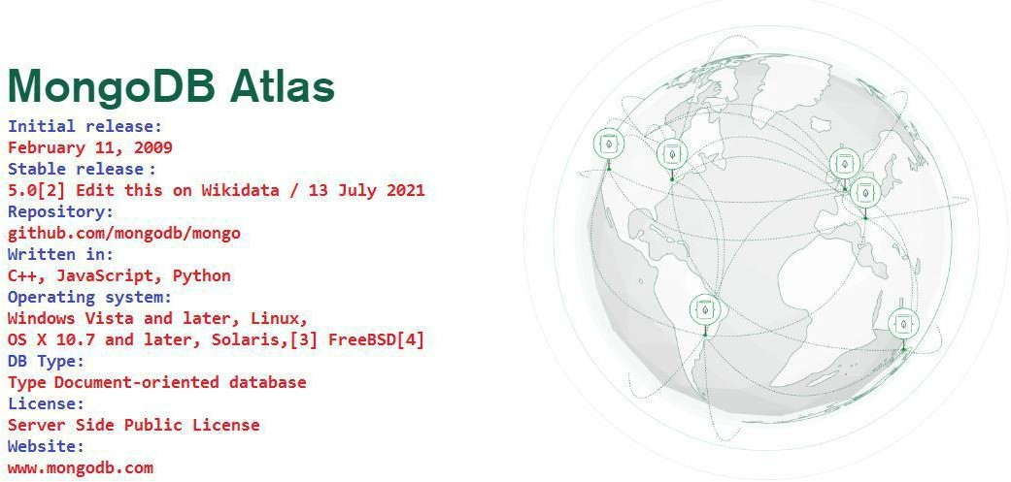
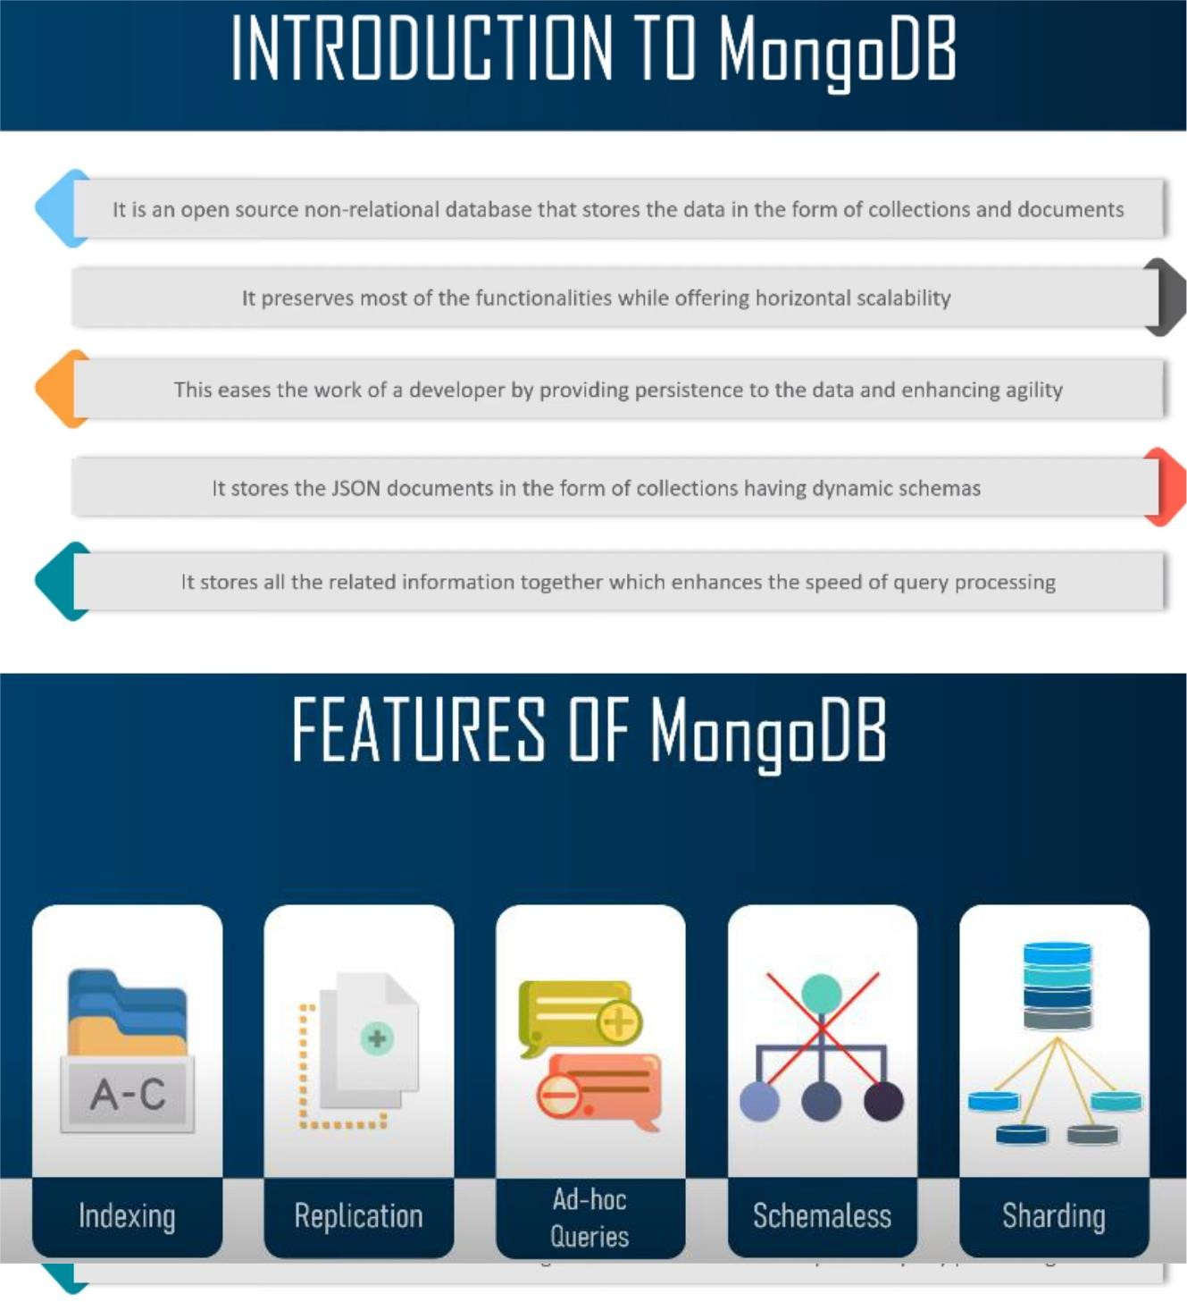

Official Site Doc Link: https://docs.mongodb.com/manual/crud/ https://docs.mongodb.com/manual/tutorial/query-documents/

MongoDB

It is a cross-platform, document oriented database that provides, high performance,
high availability, and easy scalability. MongoDB works on concept of collection and document.

Database
Database is a physical container for collections. Each database gets its own set of files on the
file system. A single MongoDB server typically has multiple databases.

Collection
Collection is a group of MongoDB documents. It is the equivalent of an RDBMS table. A
collection exists within a single database. Collections do not enforce a schema. Documents
within a collection can have different fields. Typically, all documents in a collection are of
similar or related purpose.

Document
A document is a set of key-value pairs. Documents have dynamic schema.
Dynamic schema
means that documents in the same collection do not need to have the same set of fields or
structure, and common fields in a collection's documents may hold different types of data.
The following table shows the relationship of RDBMS terminology with MongoDB

Any relational database has a typical schema design that shows number of tables and the
relationship between these tables. While in MongoDB, there is no concept of relationship.

Advantages of MongoDB over RDBMS

Schema less: MongoDB is a document database in which one collection holds different
documents. Number of fields, content and size of the document can differ from one
document to another.
Structure of a single object is clear. No complex joins.
Deep query-ability. MongoDB supports dynamic queries on documents using a document-based query language that's nearly as powerful as SQL.
Tuning.

Ease of scale-out: MongoDB is easy to scale.
Conversion/mapping of application objects to database objects not needed.
Uses internal memory for storing the (windowed) working set, enabling faster access
of data.

Why Use MongoDB?
Document Oriented Storage: Data is stored in the form of JSON style documents.
Index on any attribute
Replication and high availability Auto-sharding
Rich queries
Fast in-place updates
Professional support by MongoDB

Where to Use MongoDB?
Big Data
Content Management and Delivery Mobile and Social Infrastructure User Data Management
Data Hub

Sharding.
Sharding is the process of splitting data up across machines. We also use the term “partitioning” sometimes to describe this concept. We can store more data and handle more load without requiring larger or more powerful machines, by putting a subset of data on each machine.
In the figure below, RS0 and RS1 are shards. MongoDB’s sharding allows you to create a cluster of many machines (shards) and break up a collection across them, putting a subset of data on each shard. This allows your application to grow beyond the resource limits of a standalone server or replica set.

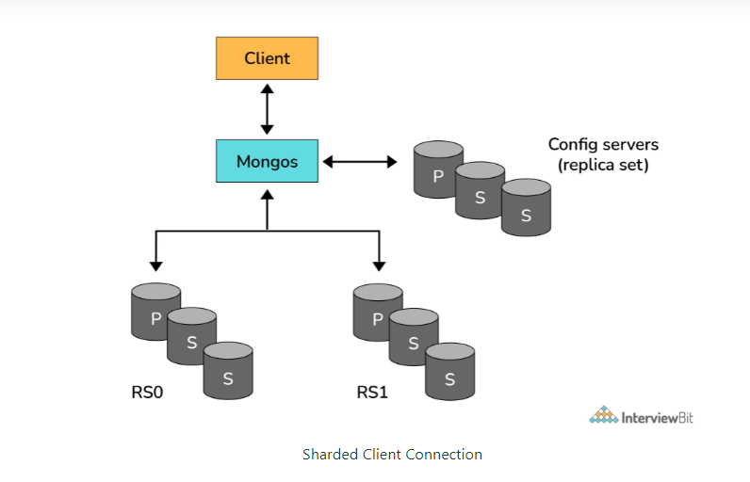

Aggregation Framework in MongoDB?
- The aggregation framework is a set of analytics tools within MongoDB that allow you to do analytics on documents in one or more collections.
- The aggregation framework is based on the concept of a pipeline. With an aggregation pipeline, we take input from a MongoDB collection and pass the documents from that collection through one or more stages, each of which performs a different operation on its inputs (See figure below). Each stage takes as input whatever the stage before it produced as output. The inputs and outputs for all stages are documents—a stream of documents.

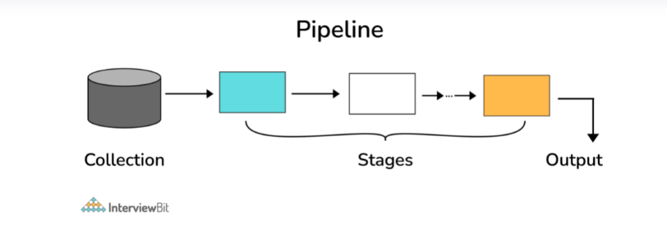

Replica Set in MongoDB?
To keep identical copies of your data on multiple servers, we use replication. It is recommended for all production deployments. Use replication to keep your application running and your data safe, even if something happens to one or more of your servers.
Such replication can be created by a replica set with MongoDB. A replica set is a group of servers with one primary, the server taking writes, and multiple secondaries, servers that keep copies of the primary’s data. If the primary crashes, the secondaries can elect a new primary from amongst themselves

Architecture in MongoDB.

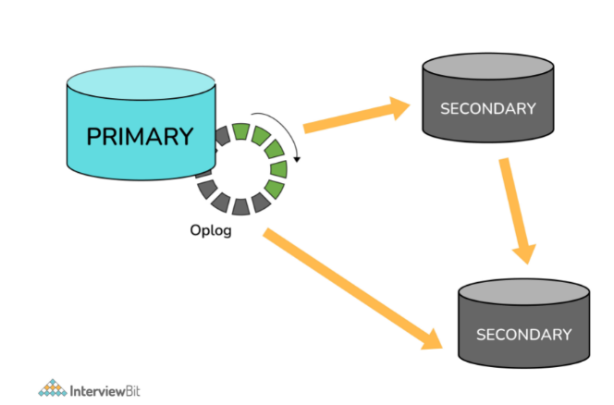

some utilities for backup and restore in MongoDB?
The mongo shell does not include functions for exporting, importing, backup, or restore. However, MongoDB has created methods for accomplishing this, so that no scripting work or complex GUIs are needed. For this, several utility scripts are provided that can be used to get data in or out of the database in bulk. These utility scripts are:
- mongoimport
- mongoexport
- mongodump
- mongorestore

Installation:-

Mongo DB From Below URL (32 Bit) https://www.mongodb.org/dl/win32/i386
Download File :- (mongodb-win32-i386-v3.2-latest-signed.msi) and install. Now create a Project Like (D:\MERN\NodeExpressMongo_Project)
open CMD
- npm init
replace index.js to app.js

you will get your package.json file. Now install some dependencies.
- npm install express
>npm install mongodb
>npm install mongoose
>npm install -g nodemon –save-dev

Package.json -

{
"name": "nodeexpressmongo_project", "version": "1.0.0",
"description": "",
"main": "app.js", "scripts": {
"start": "nodemon app.js"// replace test with start.

},

"dependencies": {

},
"devDependencies": {

}
}

Configuring:- environment Variable C:\Program Files\MongoDB\Server\3.2\bin
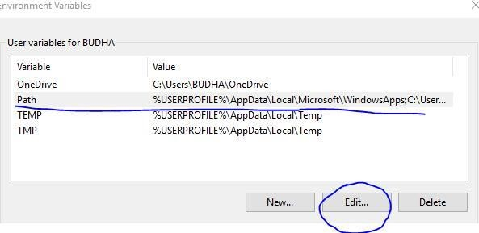

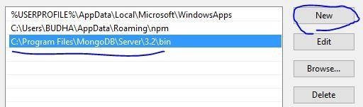

Create a folder as below (To save data in local Mongo DB): -

C:\data\db

Go to your Project path and open cmd and run below command to start server (only for 32 bit PC.)
D:\MERN\NodeExpressMongo_Project>mongod --storageEngine=mmapv1 -- dbpath "C:\data\db"

you will get below screen
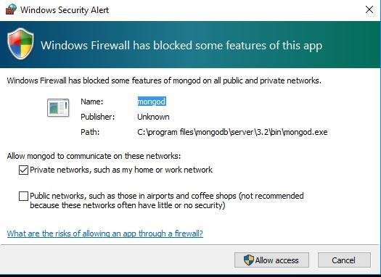

for 64 bit PC
D:\MERN\NodeExpressMongo_Project>mongod

IF your Server started successfully you will see below screen.
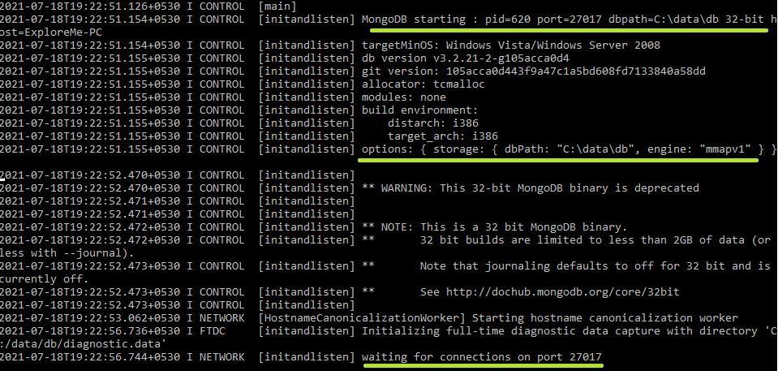

You need to open two terminal
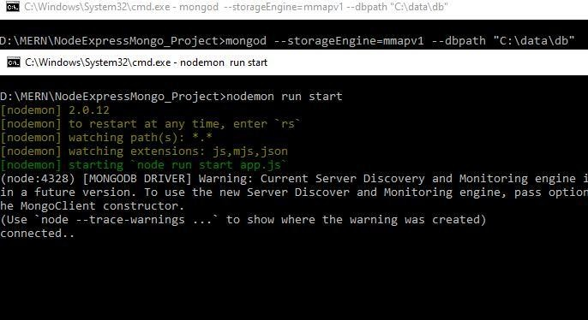
Open new command prompt and run below command

- D:\MERN\NodeExpressMongo_Project>mongod -- storageEngine=mmapv1 --dbpath "C:\data\db"
(to keep server running)

Again Open new command prompt and run below command
- D:\MERN\NodeExpressMongo_Project>nodemon run start

to run your application.

Adding Code to get response using PostMan

Now create a app.js file and add below code.

const express = require('express'); const mongoose = require('mongoose'); const url = 'mongodb://localhost/MENApp'; const app = express();

mongoose.connect(url, {useNewUrlParser: true}); const con = mongoose.connection; con.on('open', () => {

});

const customRoute = require('./Router/menappRoute'); app.use('/details', customRoute); // this is a middleware. app.listen(9000, () => {

});

IF your server work correctly you will get connected… message in CMD. Now we need to create Router to use (GET/POST/PATCH/DELETE Operations) so create a folder let say Router → menAppRoute.js and add below code
const express = require('express'); const router = express.Router();

});
module.exports = router;

Now press send button of your Postman. (URL : http://localhost:9000/details)

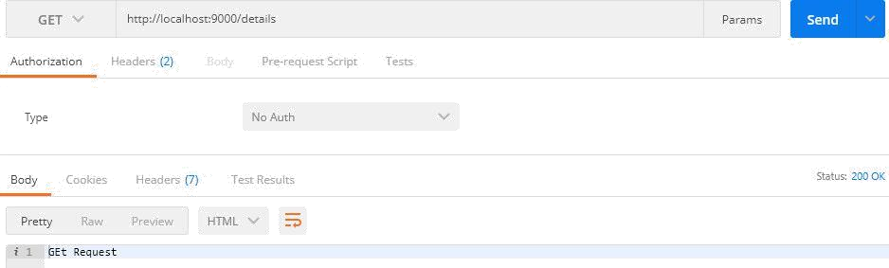

MONGO DB COMMANDS

To run mongo commands first you have to open a new command prompt and run below command (for 32 bit) to keep database active and in running state.

Open new command prompt and run below command
- mongod --storageEngine=mmapv1 --dbpath "C:\data\db"(mongod for 64 bit)

Again Open new command prompt and run below command

nodemon run start

Again Open new command prompt and run below command
- mongo

you will see a shell like below with a cursor blinking.

STEP BY STEP

TO CONNECT WITH MONGODB
>mongod

TO RUN MONGO COMMAND
>mongo

TO SEE ALL EXISTING DATABASES
>show dbs

TO SELECT ANY DATABASE
>use xyz_db

TO SEE COLLECTIONS/TABLES
>show collections

TO CREATE COLLECTIONS/TABLES
>db.createCollection("xyz_employees")

TO DELETE COLLECTION
>db.collection_name.drop()

TO DELETE DATABASE
>db.dropDatabase()

TO SEE IST OF DB COMMANDS
>db.help()

TO CREATE A COLLECTIONS/TABLES AND INSERT DOCUMENT/RECORD
>db.xyz_employees2.insertOne({"first_name": "James"}) // it will create a collection xyz_employees2 and then insert the object.

TO CREATE COLLECTIONS/TABLES WITH FIXED DOCUMENT/RECORD OF MAX SIZE.
>db.createCollection('logs', {capped: true, size: 2048, max: 2})
>db.logs.insertOne({'count': 1})
>db.logs.insertOne({'count': 2})
>db.logs.insertOne({'count': 3})

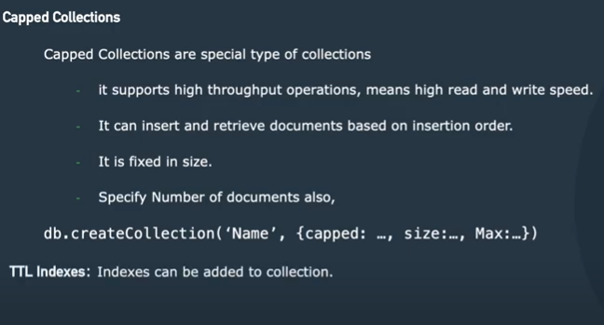

INSERT MULTIPLE RECORDS

>db.employee.insertMany([{'name':'Virat', 'department': 'computers', 'salary':30000},{'name': 'Rahul', 'department': 'commerce','salary': 20000},{'name':'Priya','department': 'science', 'salary': 40000}])

TO SEE DOCUMENT/RECORD
>db.logs.find().pretty()
// output
{“_id”: ObjectId(“5ef53d1eef7290308c8e4404), “count”: 2}
{“_id”: ObjectId(“7ef53d1eef0976308c8e4212), “count”: 3}

count: 1 will be removed and newest entry will be inserted as max legth is 2 only.
This is useful for loggers where we use some authentcation for logging.

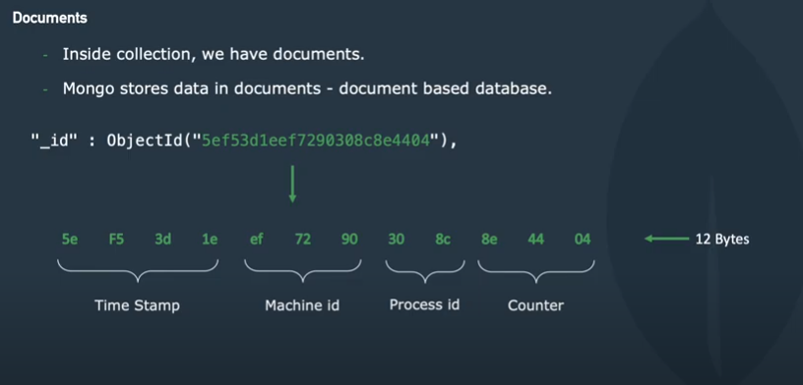

TO SEE LIST OF DB COMMANDS
>db.db_name.help()

TO DROP A COLLECTIONS
>db.collection_name.drop()

TO SEE LIST OF COLLECTION COMMANDS
>db.collection_name.help()
------------------------------------------------------------------------------
To exit from mongodb.
>quit()

To see server related details
>db.serverCmdLineOpts()

To see information related to server , host and some other info.

db.employee.find().explain('executionStats')

To check db is a Master db
db.isMaster()

Data in mogodb is stored in bson (Binary JSON) formt.

Note : if you insert records more than maxWriteBtachSize, Mongo db will create two seperate batches to execute the operation.

Updating specific field inside any record.

- db.cars.update({name: 'honda'}, {$set: {name: 'Ford'}})

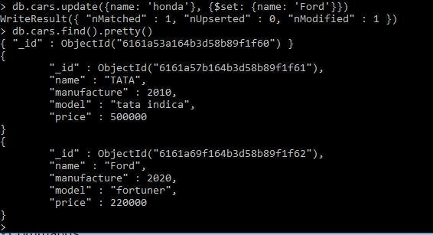

ADDING NEW FIELD TO EXISTING RECORD
- db.cars.update({name: 'Ford'}, {$set: {quantity: 400}}, {$upsert: true})

INSERT NESTED RECORDS
> db.employee.update({'name': 'Virat'}, {$set: {'address': {'street': 'abc street'}}}, {$upsert: true})

DELETE ANY SPECIFIC RECORD FROM COLLECTIONS
> db.employee.remove({name: 'Virat' })

SEE SPECIFIC RECORD ONLY
>db.employee.find({name: ‘Priya’}).pretty()

FIND SPECIFIC RECORD GIVING SOME PARAMETER
>db.employee.find( { "monthlySalary": { $elemMatch: { "name" : "Priya"}}}).pretty();

FIND ALL
>db.employee.find({}).pretty()

SEARCH QUERIES

SEARCH BY TEXT
To search by text, you need to add index as text.
>db.employee.createIndex({name: 'text'})
>db.employee.find({$text: {$search: "\"Priya\""}}).pretty()

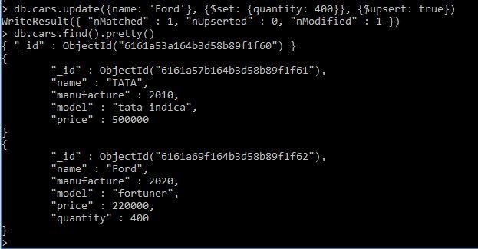

RENAME A SPECIF FIELD
> db.employee.update({'name': 'Virat'}, {$rename: {'salary': 'monthlySalary'}})

RENAME ALL FIELDS
> db.employee.update({},{$rename: {'salary': 'monthlySalary'}})

The SET Modifier in MongoDB?
If the value of a field does not yet exist, the "$set" sets the value. This can be useful for updating schemas or adding user-defined keys.
Example:
> db.users.findOne()
{
"_id" : ObjectId("4b253b067525f35f94b60a31"),
"name" : "alice",
"age" : 23,
"sex" : "female",
"location" : "India"
}
To add a field to this, we use “$set”:
> db.users.updateOne({"_id" :
ObjectId("4b253b067525f35f94b60a31")},
... {"$set" : {"favorite book" : "Start with Why"}})

